Evaluating Touchscreen Usability for Blind People
(Title: Garamond, 16 pt; less than 12 words)

One major trend in research and development of ICT learning tools is universal design for learning. Although the universal design posits that every learner should have equal access to learning, its focus is on general access rather than ease of use for people with particular needs. Many ICT tools for disabled people are targeted to support the needs of learners with specific disabilities, which calls for a validated usability evaluation criteria for those tools reflecting opinions of all the related parties such as learners, parents, teachers, developers and researchers. (Abstract: Garamond, 10 pt, 100-150 words)

Keywords: Evaluation, Touchscreen, Usability (up to 5 keywords in Alphabetical order)

Issues of Usability
(Heading 1: Garamond, 13pt, Center, Bold)

Touchscreen Usability Test (Heading 2: Garamond, 11pt, Bold)

To carry out this task, researchers proposed a framework for analyzing various dimensions representing ICT learning tools. The basis of the framework consists of three dimensions: Interface (screen layout, menu design, etc.), learning (support for various learning tasks, interaction, etc.), and technology (compatibility, error prevention, stability, etc.). Each dimension was categorized into efficiency, efficacy, and satisfaction. (Body Text: Garamond, 10pt)

Preparation of the test. (Heading 3: Garamond, 10pt, Bold) XXXXXX XXXXXXXXXXX
XXXXXXXXXXXXXXXXXXXXXXXXXXXXXXXXXXXXXXXXXXXXXXXXXXX
Table 1
Analysis Results
IV | DV | SS | df | MS | F | p
Scaffolding type | Test scores | 304.71 | 1 | 304.71 | .86 | .36
 | Self-efficacy | 650.13 | 1 | 650.13 | 4.35 | .04

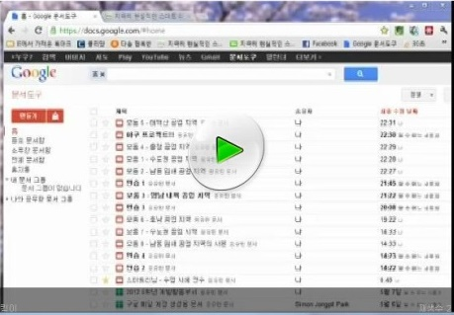
Figure 1. Descriptive phrase that serves as title and description

References
(Garamond 13 pt, Confirm to the APA - 6th edition style)

Cho, K., & Jonassen, D. H. (2002). The effects of argumentation scaffolds on argumentation and problem solving. Educational Technology Research and Development, 50(3), 5-22.
Dabbagh, N. (2003). Scaffolding: An important teacher competency in online learning. TechTrends for Leaders in Education and Training, 47(2), 39-44.
Ohler, J. (2007). Digital storytelling in the classroom. New York, NY: St. Martins Press.
Smeda, N., Dakich, E., & Sharda, N. (2012). Digital storytelling with Web 2.0 tools for collaborative Learning. In A. L. P. Okada, T. Connolly, & P. J. Scott (Eds.), Collaborative learning 2.0: Open educational resources (pp. 145-163). Hershey, PA: IGI Global.
(Garamond, 10 pt)

